PHASE 8 : Create Reports on Employee Test Table

Navigation Steps :

- Open All menus, Search for Reports.

- Under Usage and governance Select Reports.

- Click the New button to create a new report.

- Create 3 Reports as follows.

Report 1: Employees by Department

- In Data

- Report name : Employees by Department.

- Source Type : Table.

- Table : Employee Test, Now click the Next button.

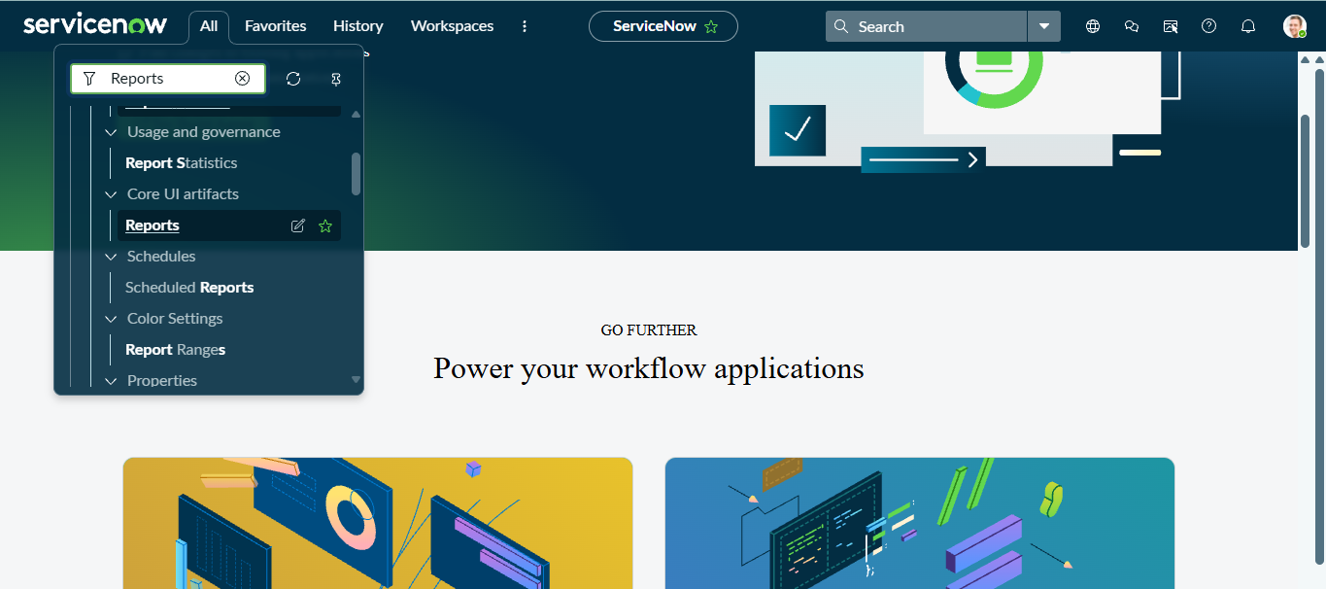
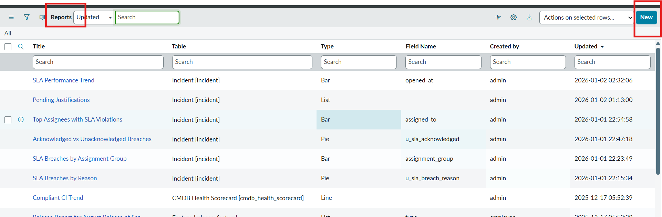

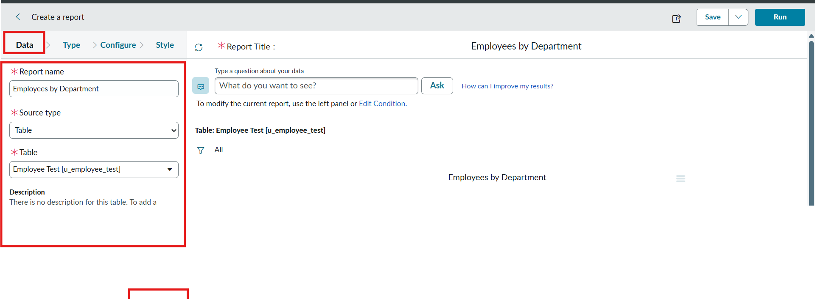
- Now after Clicking next in type Select Pie chart .
- And click the next button.
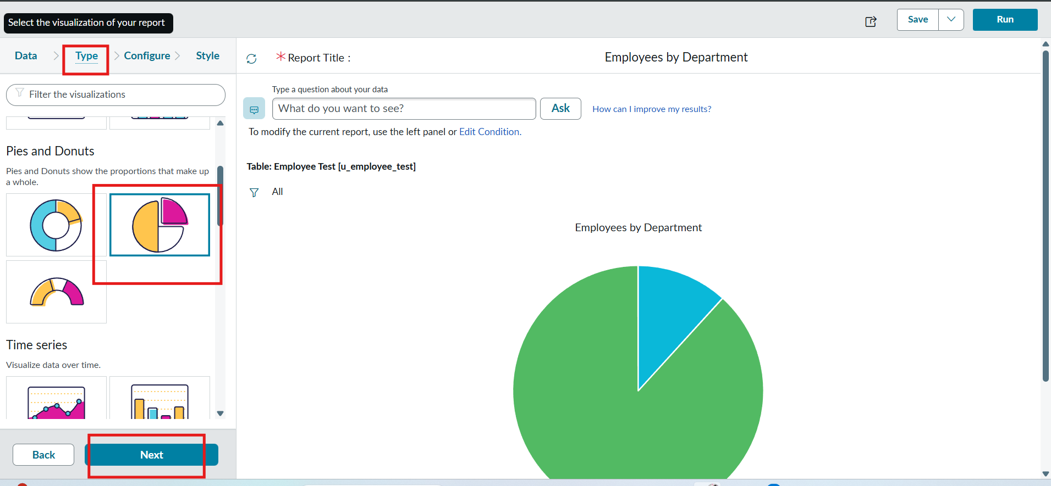
- Now In Configure Select Group by Department Field.

- In the Aggregation Field Select Count.

- Then Click next.

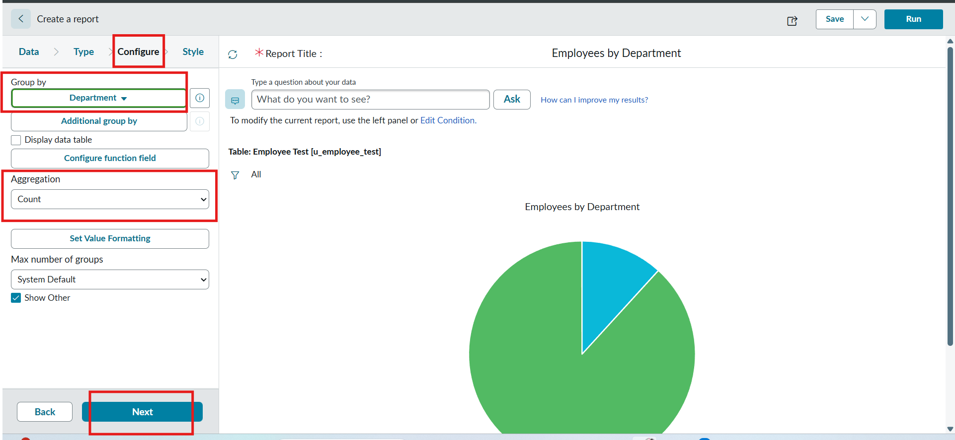
- Now In Style Leave the Chart color by default.

- And Click the Run button to Execute the given data Report.

- And Click save button to Save the Report.

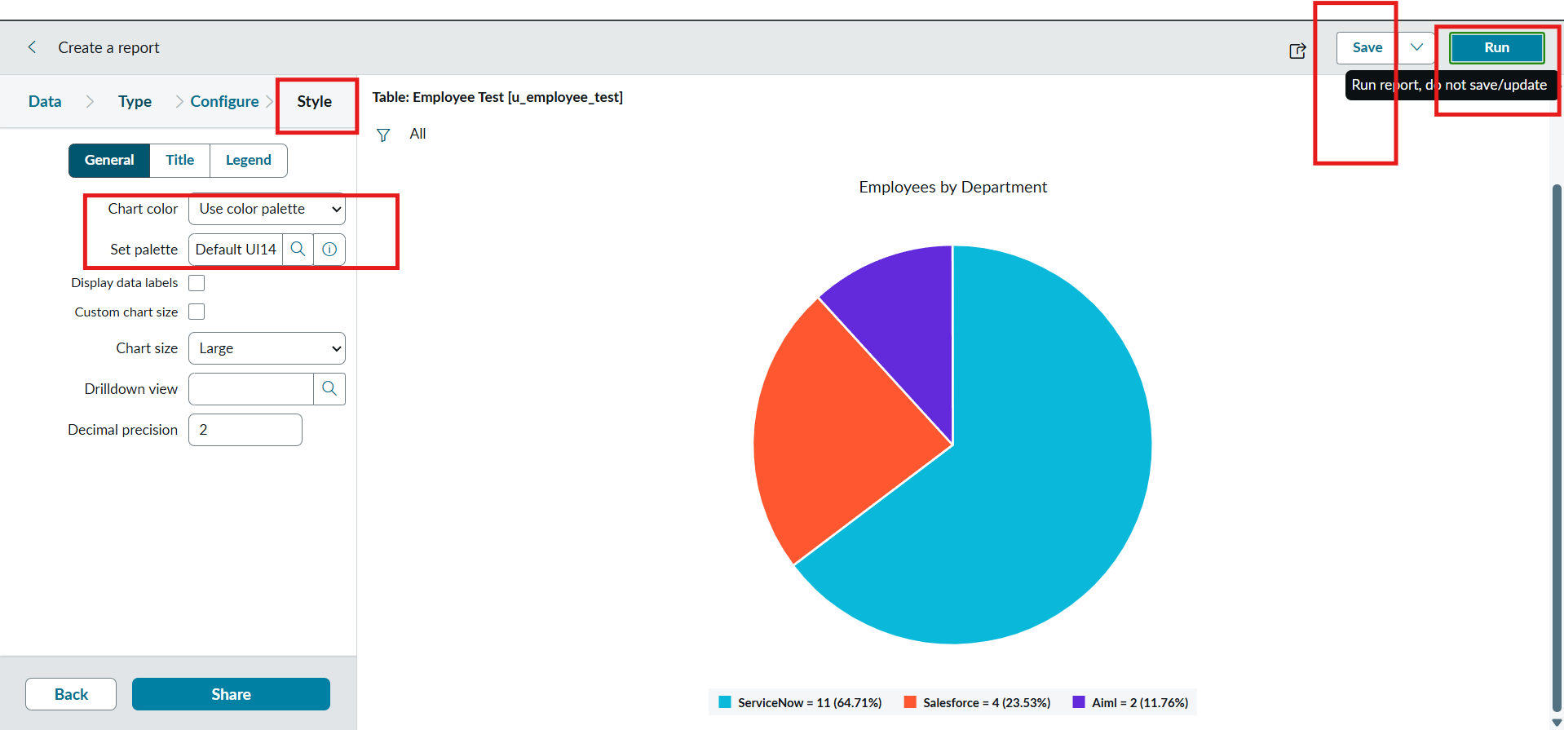

Report 2: Employees by Location
Configuration
- Table: Employee Test
- Type: Bar Chart
- Aggregation: Count
- Group By: Location
Steps :
- Create a New Report.

- Report name : Employees by Location.

- Table Select : Employee Test.

- Select Type : Bar Chart.

- In Configure Select Group by Field : Location.

- And Aggregation is Count.

- Now Click Run to Execute the Report and Click the Save to save the Report.
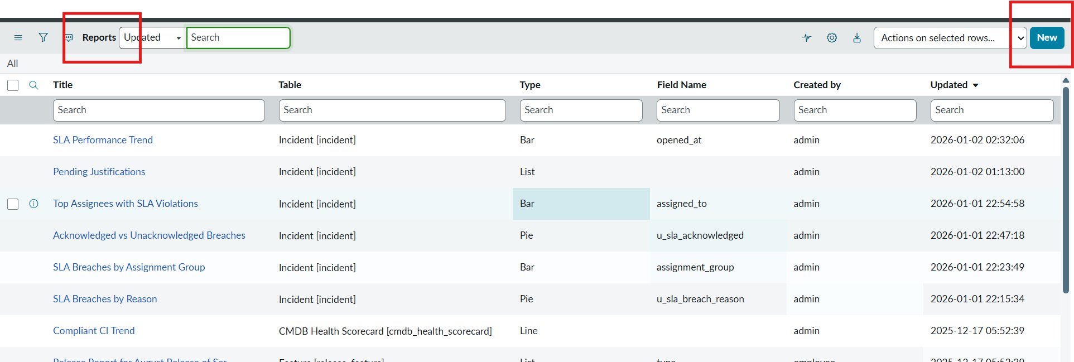

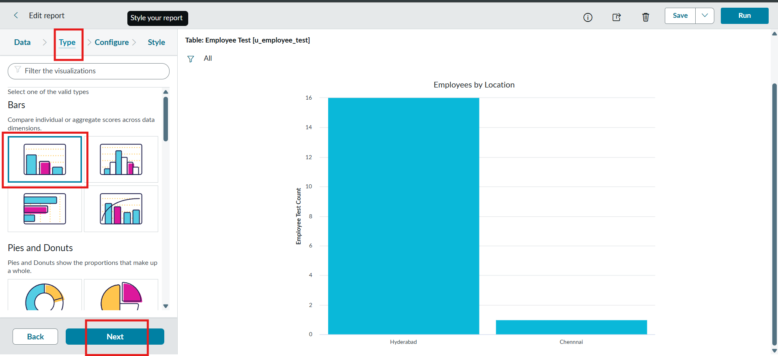
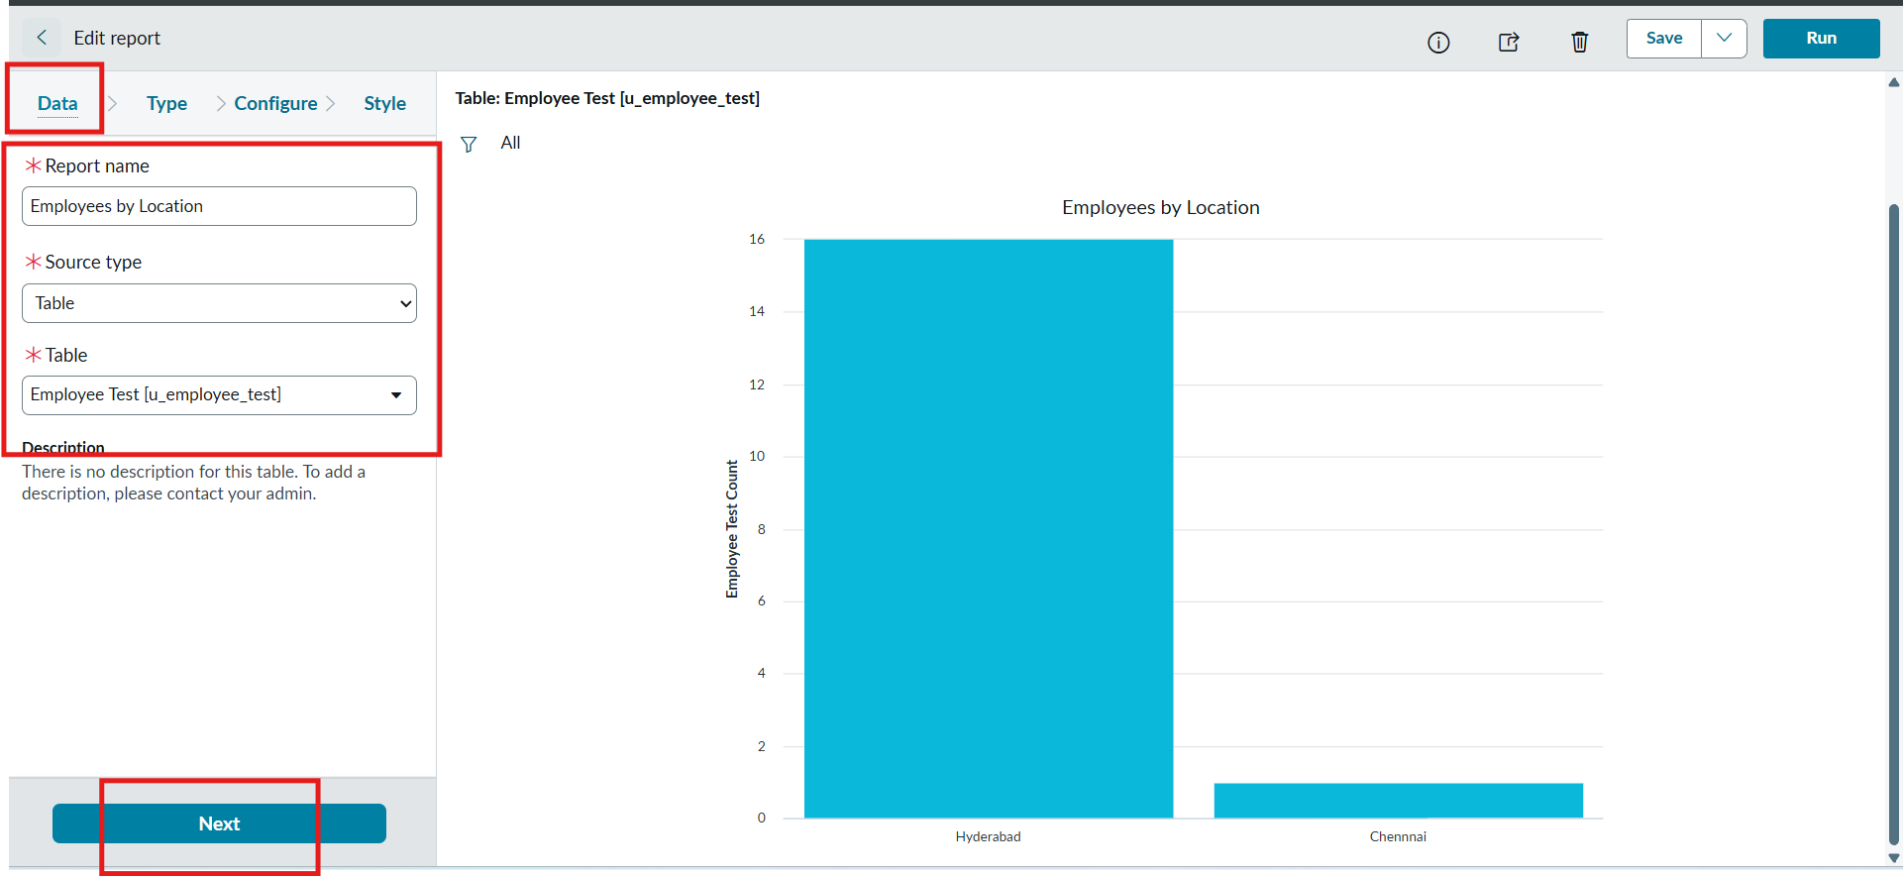
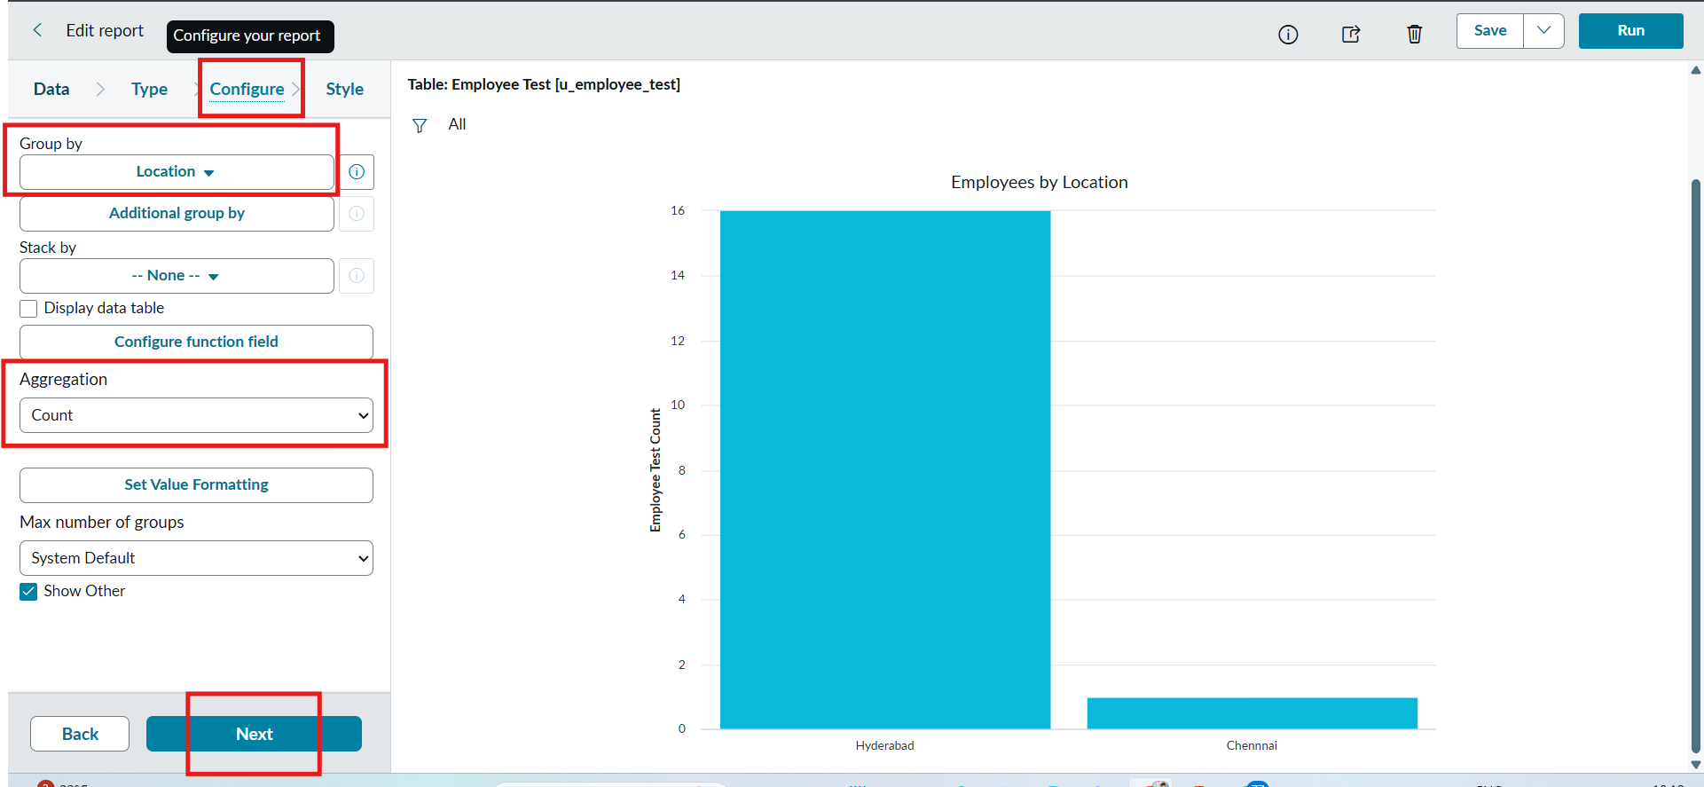

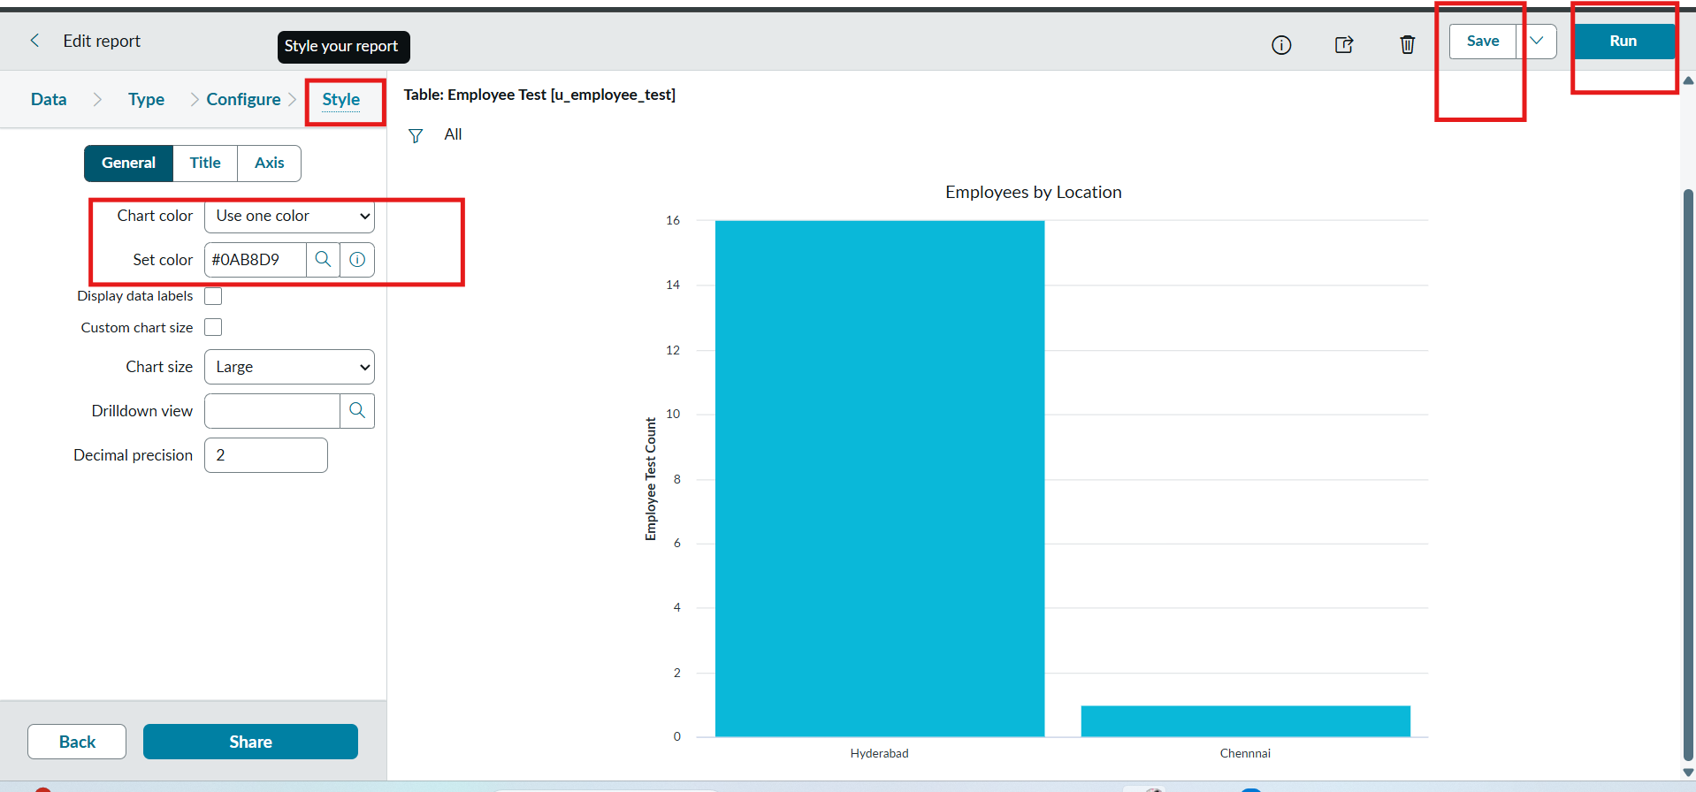

Report 3: Employee List Report.

Configuration
- Create a New Report name : Employee List Report.

- Table: Employee Test.

- Select Type: List.

- In Configure Select Columns:
  - Employee ID.
  - Employee Name.
  - Email.
  - Department.
  - Location.

- Now Select next and no required to choose anything in Style.

- Now Click Run to Execute the Report and Click Save to Save the Report.
